BATTLEFIELD OF KERBALA

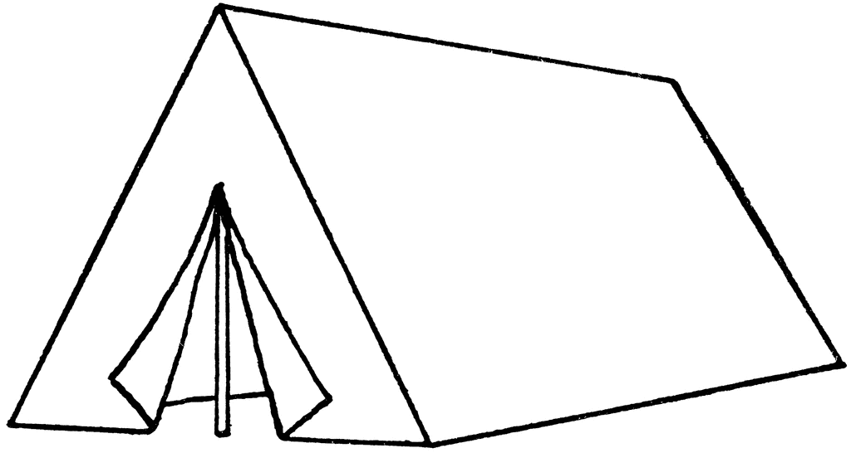

YAZID’S

ARMY

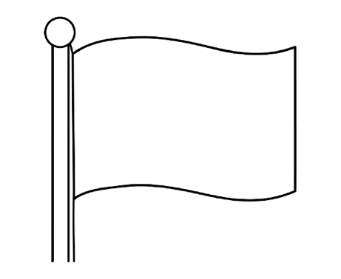

YA

HUSSAIN

RIVER FURAT